

Name Abdul Rahim

Roll No 2K24/CSE/14

Assignment Topic Lab Tasks

Subject HCI & CG

Submitted to Sir Rajesh Kumar

TASK 1 :

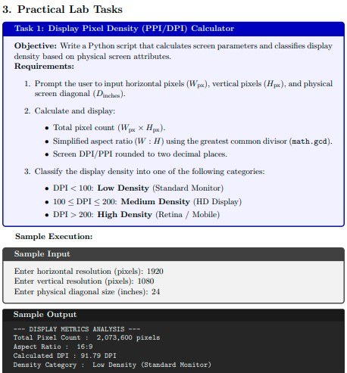

CODE :

import math

def calculate_display_metrics():
# Prompt user inputs
w_px = int(input("Enter horizontal resolution (pixels): "))
h_px = int(input("Enter vertical resolution (pixels): "))
d_inches = float(input("Enter physical diagonal size (inches): "))

# 1. Total pixel count
total_pixels = w_px * h_px

# 2. Aspect Ratio calculation using math.gcd
gcd_val = math.gcd(w_px, h_px)
aspect_w = w_px // gcd_val
aspect_h = h_px // gcd_val

# 3. Calculated DPI / PPI
diagonal_pixels = math.sqrt(w_px**2 + h_px**2)
dpi = diagonal_pixels / d_inches

# 4. Density Classification
if dpi < 100:
category = "Low Density (Standard Monitor)"
elif 100 <= dpi <= 200:
category = "Medium Density (HD Display)"
else:
category = "High Density (Retina / Mobile)"

# Display Output
print("\n--- DISPLAY METRICS ANALYSIS ---")
print(f"Total Pixel Count: {total_pixels:,} pixels")
print(f"Aspect Ratio: {aspect_w}:{aspect_h}")
print(f"Calculated DPI: {dpi:.2f} DPI")
print(f"Density Category: {category}")

if __name__ == "__main__":
calculate_display_metrics()

OUTPUT:

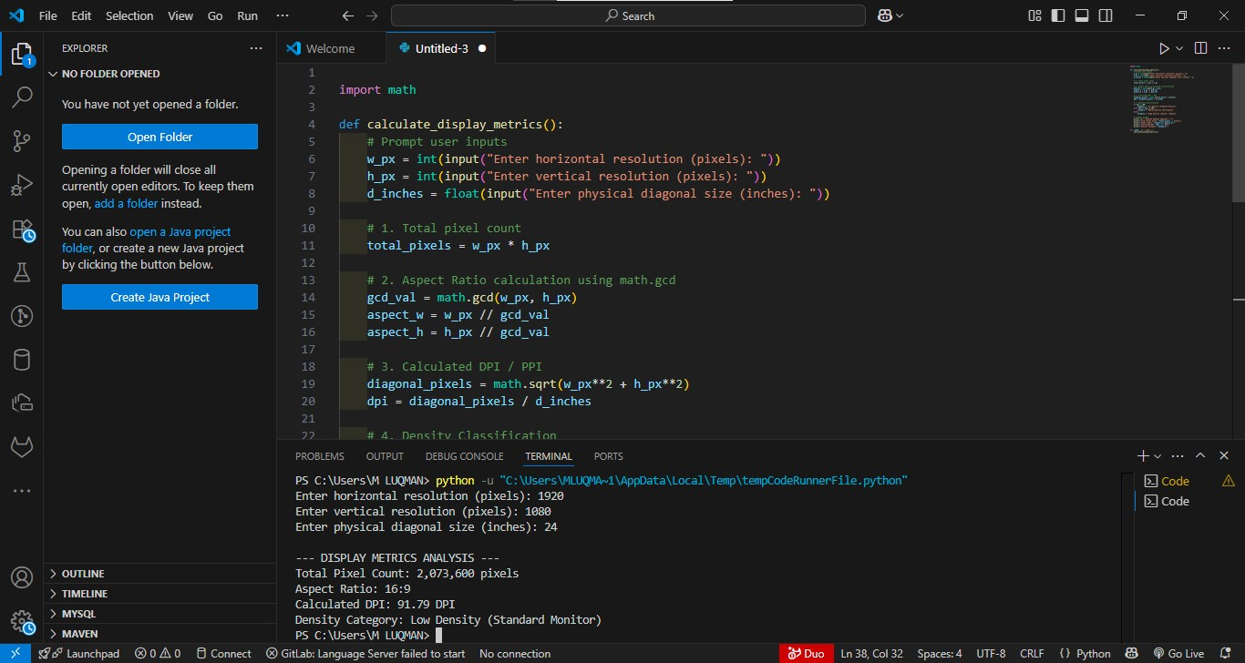

TASK 2 :

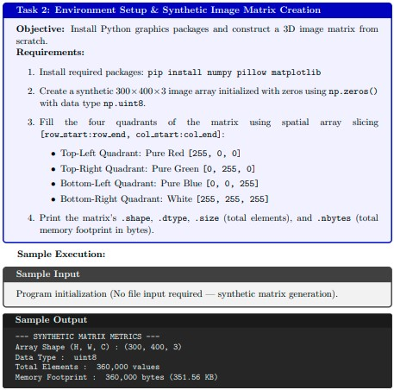

CODE :

import numpy as np

# Create synthetic 300x400x3 array initialized with zeros (uint8)
height, width, channels = 300, 400, 3
synthetic_img = np.zeros((height, width, channels), dtype=np.uint8)

# Midpoint calculations for slicing
half_h = height // 2
half_w = width // 2

# Fill quadrants [row_start:row_end, col_start:col_end]
synthetic_img[0:half_h, 0:half_w] = [255, 0, 0] # Top-Left: Pure Red
synthetic_img[0:half_h, half_w:width] = [0, 255, 0] # Top-Right: Pure Green
synthetic_img[half_h:height, 0:half_w] = [0, 0, 255] # Bottom-Left: Pure Blue
synthetic_img[half_h:height, half_w:width] = [255, 255, 255] # Bottom-Right: White

# Calculate metrics
shape = synthetic_img.shape
dtype = synthetic_img.dtype
total_elements = synthetic_img.size
nbytes = synthetic_img.nbytes
nbytes_kb = nbytes / 1024

print("--- SYNTHETIC MATRIX METRICS ---")
print(f"Array Shape (H, W, C): {shape}")
print(f"Data Type: {dtype}")
print(f"Total Elements: {total_elements:,} values")
print(f"Memory Footprint: {nbytes:,} bytes ({nbytes_kb:.2f} KB)")
OUTPUT :

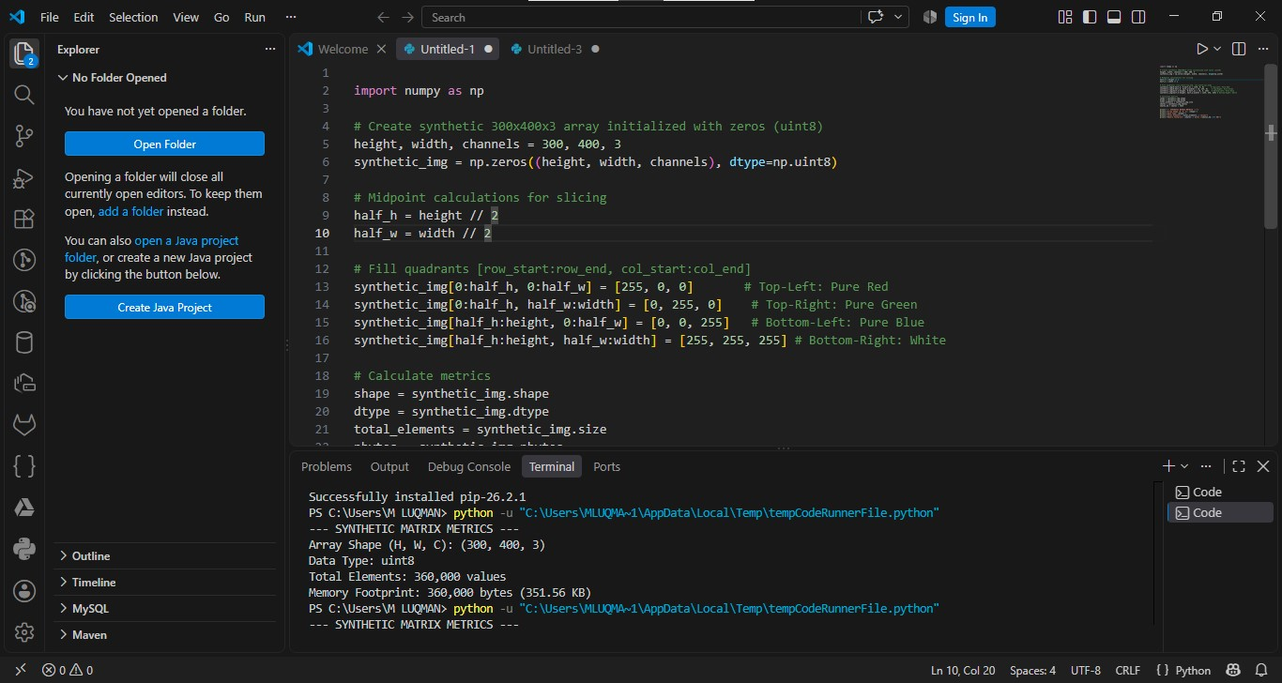

TASK 3 :

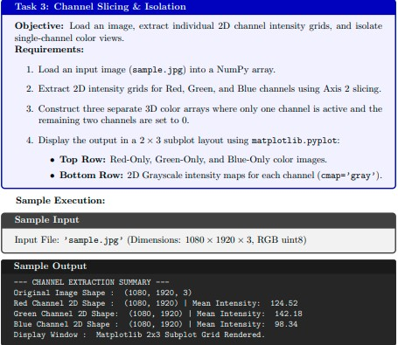

CODE :

import numpy as np
import matplotlib.pyplot as plt
from PIL import Image

# 1. Load an input image
image_path = 'sample.jpg'
img = np.array(Image.open(image_path))

# 2. Extract 2D intensity grids using Axis 2 slicing
red_2d = img[:, :, 0]
green_2d = img[:, :, 1]
blue_2d = img[:, :, 2]

# Print Channel Extraction Summary
print("--- CHANNEL EXTRACTION SUMMARY ---")
print(f"Original Image Shape: {img.shape}")
print(f"Red Channel 2D Shape: {red_2d.shape} | Mean Intensity: {red_2d.mean():.2f}")
print(f"Green Channel 2D Shape: {green_2d.shape} | Mean Intensity: {green_2d.mean():.2f}")
print(f"Blue Channel 2D Shape: {blue_2d.shape} | Mean Intensity: {blue_2d.mean():.2f}")

# 3. Construct 3D isolated color arrays
red_isolated = np.zeros_like(img)
red_isolated[:, :, 0] = red_2d

green_isolated = np.zeros_like(img)
green_isolated[:, :, 1] = green_2d

blue_isolated = np.zeros_like(img)
blue_isolated[:, :, 2] = blue_2d

# 4. Display 2x3 subplot layout
fig, axes = plt.subplots(2, 3, figsize=(15, 8))

# Top Row: Isolated Color Channels
axes[0, 0].imshow(red_isolated)
axes[0, 0].set_title("Red Channel Only")
axes[0, 0].axis('off')

axes[0, 1].imshow(green_isolated)
axes[0, 1].set_title("Green Channel Only")
axes[0, 1].axis('off')

axes[0, 2].imshow(blue_isolated)
axes[0, 2].set_title("Blue Channel Only")
axes[0, 2].axis('off')

# Bottom Row: 2D Grayscale Intensity Maps
axes[1, 0].imshow(red_2d, cmap='gray')
axes[1, 0].set_title("Red Grayscale Intensity")
axes[1, 0].axis('off')

axes[1, 1].imshow(green_2d, cmap='gray')
axes[1, 1].set_title("Green Grayscale Intensity")
axes[1, 1].axis('off')

axes[1, 2].imshow(blue_2d, cmap='gray')
axes[1, 2].set_title("Blue Grayscale Intensity")
axes[1, 2].axis('off')

plt.tight_layout()
plt.show()

OUTPUT :

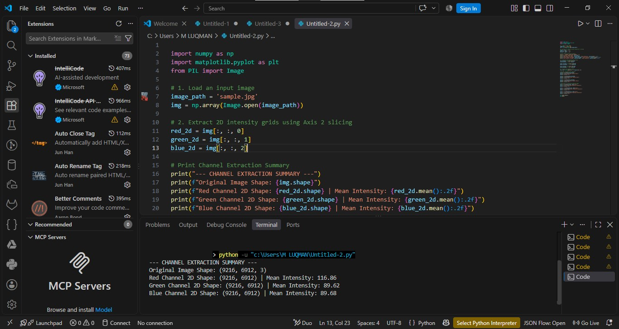

TASK 4 :

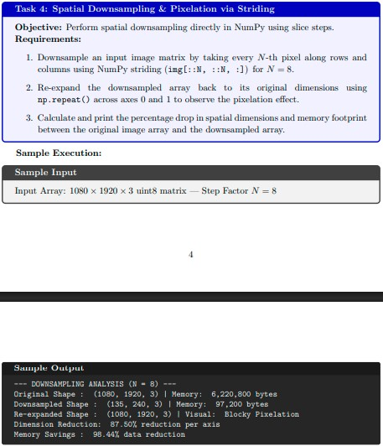

CODE :

import numpy as np
import matplotlib.pyplot as plt
from PIL import Image

# Load input image
img = np.array(Image.open('sample.jpg'))
N = 8

# 1. Downsample using slicing steps along rows and columns
downsampled = img[::N, ::N, :]

# 2. Re-expand back to original dimensions using np.repeat across axes 0 and 1
re_expanded = np.repeat(np.repeat(downsampled, N, axis=0), N, axis=1)

# Ensure shapes match original exactly if original dimensions were not perfectly divisible by N
re_expanded = re_expanded[:img.shape[0], :img.shape[1], :]

# 3. Calculate dimension reduction & memory savings
orig_mem = img.nbytes
down_mem = downsampled.nbytes

dim_reduction = (1 - (1 / N)) * 100
mem_savings = (1 - (down_mem / orig_mem)) * 100

print(f"--- DOWNSAMPLING ANALYSIS (N={N}) ---")
print(f"Original Shape: {img.shape} | Memory: {orig_mem:,} bytes")
print(f"Downsampled Shape: {downsampled.shape} | Memory: {down_mem:,} bytes")
print(f"Re-expanded Shape: {re_expanded.shape} | Visual: Blocky Pixelation")
print(f"Dimension Reduction: {dim_reduction:.2f}% reduction per axis")
print(f"Memory Savings: {mem_savings:.2f}% data reduction")

# Plot comparisons
fig, axes = plt.subplots(1, 3, figsize=(15, 5))
axes[0].imshow(img)
axes[0].set_title("Original Image")
axes[0].axis('off')

axes[1].imshow(downsampled)
axes[1].set_title(f"Downsampled (1/{N}x)")
axes[1].axis('off')

axes[2].imshow(re_expanded)
axes[2].set_title("Re-expanded (Pixelated)")
axes[2].axis('off')

plt.tight_layout()
plt.show()

OUTPUT :
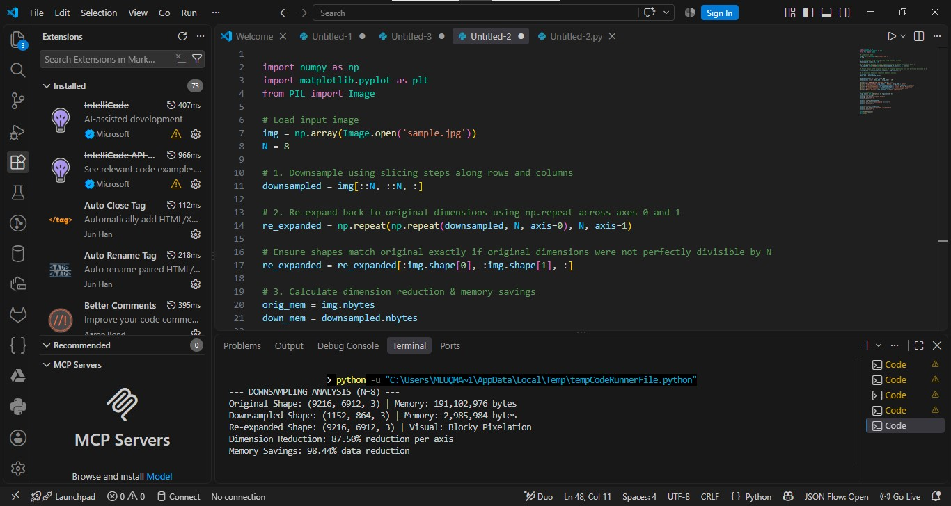

SHORT QUESTION :
Q: Why does adding an Alpha channel (RGBA) increase an image array's memory consumption by 33% compared to standard RGB?

Answer:
In a standard RGB image, each pixel stores 3 color planes (Red, Green, Blue). Adding an Alpha channel introduces a 4th plane (Transparency).
Assuming a constant data type per value (such as uint8, which uses 1 byte per channel):
- RGB Pixel Memory: $3 \text{ channels} \times 1 \text{ byte} = 3 \text{ bytes/pixel}$
- RGBA Pixel Memory: $4 \text{ channels} \times 1 \text{ byte} = 4 \text{ bytes/pixel}$
The increase in memory is:
$$\frac{4 - 3}{3} = \frac{1}{3} \approx 33.33\%$$
Since memory consumption scales linearly with the total channel dimension ($C$), going from 3 channels to 4 channels adds 1 additional byte per pixel, resulting in a 33.33% increase in total array memory footprint.

